AUgust 2023 Development Report

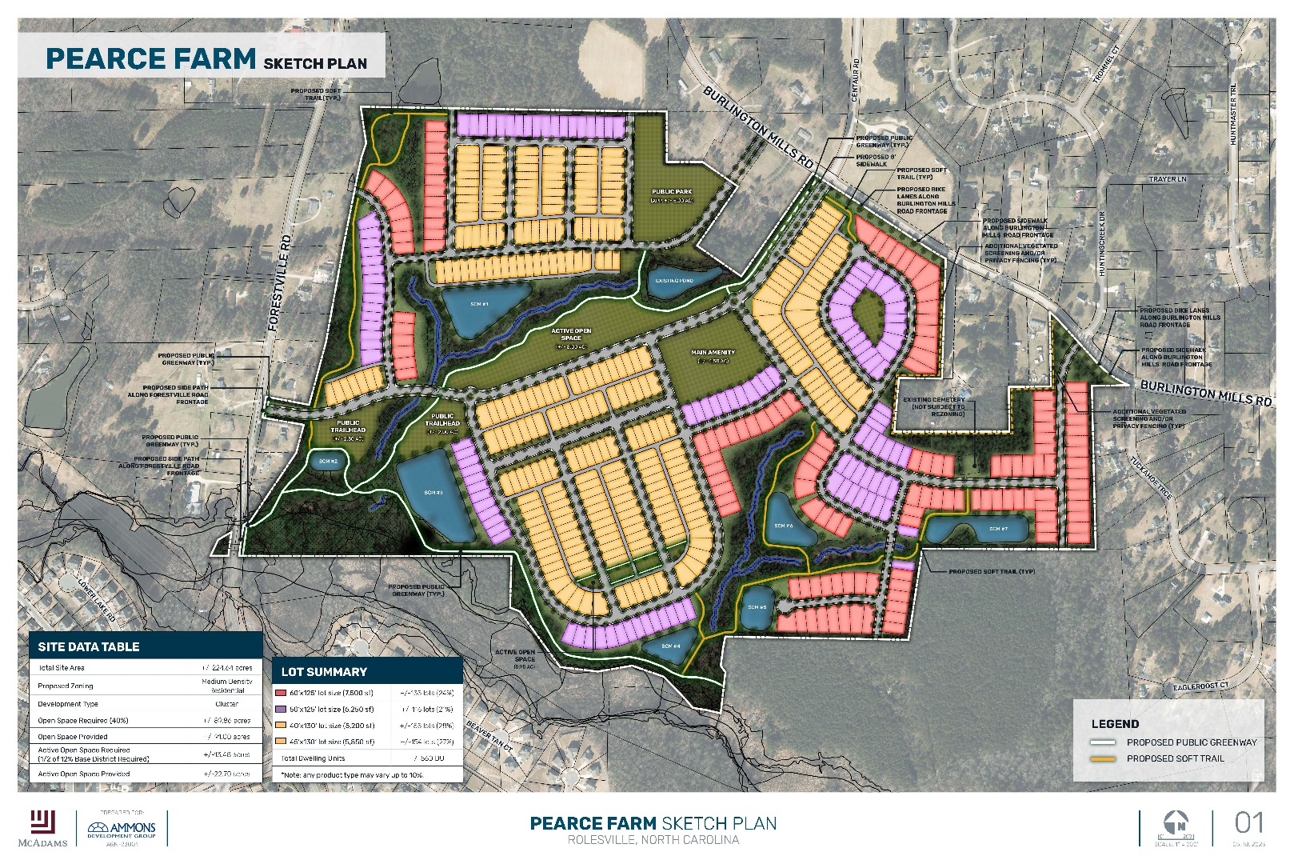

The Pearce Farm rezoning application was approved by the Town Board of Commissioners on August 1, 2023.

Please contact the Town of Rolesville Planning Department at 919-554-6517 or planning@rolesville.nc.gov for assistance or more information.
Residential Building Permits Update
[The quote is bold and distinctive. The galleries include items that are designed to coordinate with the overall look of your document]

Subdivision | Total  Buildable Lots | Total  Permits Issued  Per Development | Un-permitted  Lots Remaining | Permits Issued in Aug | Permits Issued YTD
Carlton Pointe | 301 | 301 | 0 | 0 | 1
Chandler’s Ridge | 95 | 95 | 0 | 0 | 0
Elizabeth Springs | 97 | 72 | 25 | 0 | 5
Granite Crest Phase 3C | 19 | 5 | 14 | 1 | 3
Perry Farms | 113 | 109 | 4 | 0 | 3
Preserve at Jones Dairy South | 215 | 92 | 123 | 6 | 32
Meadows at Jones Dairy | 132 | 18 | 116 | 13 | 18
Regency at  Heritage PH3 | 27 | 27 | 0 | 0 | 19
TOTAL | 999 | 719 | 282 | 20 | 81

Elizabeth Springs Townhomes | 54 | 54 | 0 | 0 | 0
A Master Teams Townhomes | 47 | 10 | 37 | 0 | 0
Townes at Carlton Pointe | 53 | 42 | 9 | 0 | 34
TOTAL | 154 | 106 | 46 | 0 | 34

ETJ/ Non-Sub
TOTAL |  |  |  | 0 | 3
TOTAL  Residential Permits Issued | 1153 | 916 | 328 | 20 | 115
Permitting Activity comparison

Development projects summary

The projects listed below are in various stages of the development process – attaining Zoning entitlements, having subdivisions plats or site development plans approved, or building through the Permit and Inspections process. For more information, please visit the Development Projects webpage on the Town of Rolesville’s website - www.rolesvillenc.gov - and either use the Interactive Map or go through the alphabetical lists of named projects.

Mixed-Use (residential and non-residential)
- Cobblestone Village – multifamily/commercial/upper-story residential
- 503 S Main Street – multi-tenant commercial/upper-story residential
- 1216 Rolesville Road – townhome/commercial
- 5109 Mitchell Mill – single-family/townhomes/commercial
- Hills at Harris Creek – single-family/townhomes/commercial
- Scarboro Apartments – multifamily/commercial
Non-residential
- Carolina Legacy Volleyball – indoor / outdoor recreation
- 971 Granite Falls Blvd – multi-tenant commercial building
- 6000 Rogers Rd – multi-tenant commercial building
- Wallbrook – various commercial buildings / tenants
- Jones Dairy Storage – self-storage
- 4724 Burlington Mills Road – age-restricted living/care facility
- 4502 Vineyard Pine Lane – multi-tenant commercial building
Residential
- Regency at Heritage – 27 Single-Family Homes
- The Townes at Carlton Pointe – 53 Townhomes
- Perry Farms Phase 2 – 33 Single-Family Homes
- A-Master Teams Townhomes – 47 Townhomes
- Chandler’s Ridge – 90 Single-Family Homes
- Elizabeth Springs – 100 Single-Family Homes & 105 Townhomes
- Granite Crest Phase 3 – 19 Single-Family Homes
- Preserve at Jones Dairy Road South – 221 Single-Family Homes
- Meadows at Jones Dairy (formerly Preserve at Jones Dairy Road North) - 132 Single-Family Homes & 63 Townhomes
- Preserve at Jones Dairy Road Central – 260 Single-Family Homes / 179 Townhomes
- The Point – 483 Single-Family Homes & 324 Townhomes
- Kalas Falls - 484 Single-Family Homes & 108 Townhomes
- Wallbrook – 140 Townhomes
- Parker Ridge – 162 single-family homes / 114 Townhomes
- Pearce Farms – approximately 550 single-family homes
- Harris Creek Farms – 64 single-family homes / 81 Townhomes
- Woodlief Assemblage – 179 single-family homes / 57 Townhomes

