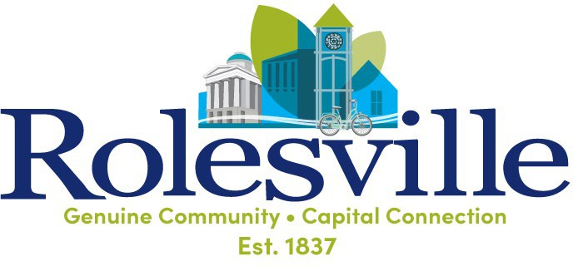

**Agenda**

**Parks & Recreation Advisory Board August 27, 2025**

**6:00 PM**

**Frank Eagles Meeting Room – Town Hall**

**ITEM AGENDA TOPIC**

1. Call to Order
2. Approval of July 23, 2025, Parks & Recreation Advisory Board Meeting Minutes
3. Old Business
4. Staff Reports
5. Year over year numbers
6. Tree Board Candidate
7. Wait Avenue Park
8. New Business
   1. 901 E Young/Gravity Commercial
9. Adjourn